Lecture 7 Clustering Aggregation

* Clustering : a group of clusters output by some clustering algorithm
* Cluster: A group of points
* Goals of clustering Aggregation
  + Compare clusterings
  + Combine the information from multiple clusterings to make a new clustering
* Disagreement Distance
  + Given two clustering’s P and C (For two partitions P and C of the dataset)
 $D\left(P, C\right)= \sum_{x,y}{Ip,c(x,y)} where$

 $Ip,c\left(x,y\right)=1 if P and C disagree which cluster x and y belong to and 0 otherwise$

+ Formally,
  + 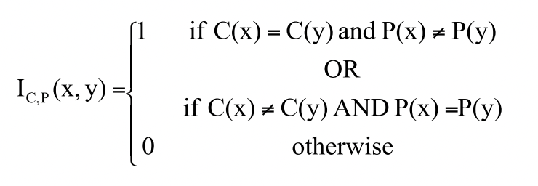
  + Disagreement distance is a measure of how different two clusterings of a set of data points are , counting the number of disagreeing object pairs between
  + P(x) is the cluster index in partition P that contains object x
  + C(x) is the cluster index in partition C that contains object x
  + Comparing rows in table not cols
  + N choose k pairs

$\frac{n}{k}= \frac{n!}{k!\left(n-k\right)!}$

| **Object** | **Cluster in C** | **Cluster in P** |
| --- | --- | --- |
| x1 | 1 | 1 |
| x2 | 1 | 2 |
| x3 | 2 | 1 |
| x4 | 3 | 3 |
| x5 | 3 | 4 |

* **(x1, x2)**:
  + P: same (1 ≠ 2) → different
  + C: same (1 = 1) → same → **Disagree → 1**
* **(x1, x3)**:
  + P: same (1 = 1)
  + C: different (1 ≠ 2) → **Disagree → 1**
* **(x1, x4)**:
  + P: different
  + C: different → **Agree → 0**
* **(x1, x5)**:
  + P: different
  + C: different → **Agree → 0**
* **(x2, x3)**:
  + P: different (2 ≠ 1)
  + C: different (1 ≠ 2) → **Agree → 0**
* **(x2, x4)**:
  + P: different
  + C: different → **Agree → 0**
* **(x2, x5)**:
  + P: different
  + C: different → **Agree → 0**
* **(x3, x4)**:
  + P: different
  + C: different → **Agree → 0**
* **(x3, x5)**:
  + P: different
  + C: different → **Agree → 0**
* **(x4, x5)**:
  + P: different (3 ≠ 4)
  + C: same (3 = 3) → **Disagree → 1**

So the total disagreement distance:

* + D(P,C)=1+1+1=3
* Aggregate Clustering
  + Can identify best number of clusters
  + Can handle and detect outliers
  + Combining clusterings can produce better results
  + Preserves privacy
  + Problem is in NP Hard